
Shaukat Khanum Memorial Hospital
Literature Survey And Data Understanding
Mehar un Nisa (09030008) & Rabia Shafique (09030003)
3/29/2010

The literature relevant survey and the descriptive statistics for the dataset of SKM

Table of Contents

1 Data Analysis 3
1.1 MRNO 3
1.2 REGISTRATION_DATE 3
1.3 DOB 3
1.4 FIRST_VISIT_DATE 3
1.5 AGE_AT_PRESENTATION 3
1.6 SEX 3
1.7 TEHSIL 3
1.8 DISTRICT 4
1.9 PROVINCE 4
1.10 COUNTRY 4
1.11 MARITAL_STATUS 4
1.12 OCCUPATION 4
1.13 RELATION 4
1.14 FAMILY_HISTORY_ICD 5
1.15 FAMILY_HISTORY_ICD_DESC 5
1.16 ADDICTION 5
1.17 PREVIOUS_TREATMENT 5
1.18 VALID_BASIS_OF_DIAGNOSIS 5
1.19 DIAGNOSIS_AT_SKM 5
1.20 DEFINITIVE_DIAGNOSIS_INSTITUTE 5
1.21 ICDO_3_DATE 6
1.22 ORGAN 6
1.23 SUBSITE 6
1.24 MORPHOLOGY 6
1.25 GRADE 6
1.26 LATERALITY 6
1.27 TUMOR_SIZE 6
1.28 REGIONAL_LYMPH_NODE_EXAMINED 6
1.29 REGIONAL_LYMPH_NODE_POSITIVE 6
1.30 SURGICAL_MARGINS 6
1.31 CLINICAL_STAGE 7
1.32 COMMENTS_CLNICAL 7
1.33 PATHOLOGICAL_STAGE 7
1.34 COMMENTS_PATHOLOGICAL 7
1.35 SEER_SUMMARY_STAGE 7
1.36 FIRST_TREATMENT_DATE 7
1.37 FIRST_TREATMENT_ICD 7
1.38 FIRST_TREATMENT_ICD_DESC 7
1.39 DATE_OF_DEATH 7
1.40 A_DEATH_CAUSE 7
1.41 CLASS_OF_CASE 8
2 Data Statistics 8
2.1 Basic Statistics 8
2.1.1 Comments 9
2.2 Correlation Matrix 9
2.2.1 Comments on Results 26
2.3 Covariance Matrix 27
2.3.1 Comments 28

3 Data Dictionary 28
4 References 29
5 Appendix A 30
6 Appendix B 36

Data Analysis
The following data analysis of the dataset is for the year 2004-2008. This analysis includes the values of different attributes and the amount of missing values for each attribute.

MRNO
(integer/single_value)
Missing Values = 0.0

REGISTRATION_DATE
(nominal/single_value)

Missing Values = 0.0

DOB

nominal/single_value)

Missing Values = 0.0

FIRST_VISIT_DATE
(nominal/single_value)

Missing Values = 88.0

AGE_AT_PRESENTATION
(nominal/single_value)
Missing Values = 0.0

SEX
(nominal/single_value)
values=[Male (26587), Female (34840)]
Missing Values = 0.0

TEHSIL
(nominal/single_value)
values=[Lahore (17992), Gujranwala (2613), Peshawar (2398), Faisalabad (2360), Lahore Cantt (2290), Sialkot (1952), Multan (1164), Sargodha (1091), Gujrat (1074), Rawalpindi (1017), Islamabad (821), Mardan (799), Karachi (795), Sahiwal (741), Sheikhupura (733), Swat (611), Nowshera (582), Okara (473), Swabi (462), Kasur (448), Daska (443), Dera Ghazi Khan (428), Mianwali (427), Wazirabad (427), Jhang (418), Quetta (412), ... and 266 more ... , Dera Murad Jamali (2), GARYUM (2), Gaddani Sub-Tehsil (2), HAVELI (2), Hub Sub-Tehsil (2), Khairpur Nathan Shah Taluka (2), Khanpur Taluka (2), Kharan (2), Kotri Taluka (2), Latifabad Taluka (2), MAMUND (2), MASHABRUM (2), Miro Khan Taluka (2), Palas (2), Risalpur (2), SHIGAR (2), SUDHNOTI (2), Sehwan Taluka (2), Sinjhoro Taluka (2), Thul Taluka (2), UPPER KURRAM (2), Ubauro Taluka (2), Hazro (1), Khan Garh Taluka (1), Khipro Taluka (1), PINDIALI (1)]

Missing Values = 675.0

DISTRICT
nominal/single_value)
values=[Lahore (20282), Gujranwala (3335), Faisalabad (2848), Sialkot (2551), Peshawar (2488), Sargodha (1511), Gujrat (1508), Multan (1262), Rawalpindi (1258), Sheikhupura (1215), Mardan (1004), Sahiwal (997), Swat (956), Okara (871), ISLAMABAD (821), Karachi (795), Kasur (777), Jhang (746), Mianwali (679), Toba Tek Singh (584), Nowshera (582), Jhelum (557), Rahim Yar Khan (556), Vehari (521), Dera Ghazi Khan (504), Swabi (502), ... and 70 more ... , Badin (16), SUDHNOTI (14), Dadu (13), Khairpur (12), Zhob (11), Barkhan (10), Bunair (10), DIAMIR (8), GILGIT (8), Mastung (8), Mirpur Khas (8), Bolan (6), Gwadar (6), Killa Saifullah (6), Kohlu (6), UNKNOWN AZAD JAMMU & KASHMIR (6), Pishin (5), Kalat (4), Lasbela (4), Malir (4), Thatta (4), Umerkot (4), Ziarat (4), GHANCHE (2), Kharan (2), Risalpur (2)]

Missing Values = 675.0

PROVINCE
(nominal/single_value)
values=[N.W.F.P (9113), AZAD JAMMU & KASHMIR (598), Punjab (47535), FEDERAL CAPITAL (821), Balochistan (762), Sind (1284), F.A.T.A (577), NORTHERN AREAS (62)]

Missing Values = 675.0

COUNTRY
(nominal/single_value)
values=[Pakistan (60798), Afghanistan (606), Kenya (2), United Arab Emirates (2), Azad Kashmir (16), Denmark (1), Tunisia (2)]

Missing Values = 0.0

MARITAL_STATUS
(nominal/single_value)
values=[MarriedMarried (50598), Single (8729), Widow (1790), Divorced (229), Widower (18), Separated (63)]
Missing Values = 0.0

OCCUPATION
(nominal/single_value)
Missing Values = 223.0

RELATION
(nominal/single_value)
values=[AUNT (939), WIFE (51), SISTER (1387), MOTHER (1471), UNCLE (428), FATHER (800), BROTHER (724), MATERNAL GRAND FATHER (21), HUSBAND (98), GRAND MOTHER (345), NIECE (90), COUSIN (642), STEP SISTER (32), GRAND FATHER (138), SON (76), UN KNOWN (80), MATERNAL GRAND MOTHER (38), NEPHEW (57), RELATIVE (8), DAUGHTER (88), BROTHER IN LAW (4), SISTER IN LAW (2), GRAND SON (28), MOTHER IN LAW (11), GRAND DAUGHTER (16), UNKNOWN (88), PATERNAL GRAND FATHER (8), FATHER IN LAW (2), PATERNAL GRAND MOTHER (6)]

Missing Values = 53749.0

FAMILY_HISTORY_ICD
(real/single_value)
Missing Values = 53700.0

FAMILY_HISTORY_ICD_DESC
(nominal/single_value)
values=[Malig0t neoplasm of breast (female), unspecified site (2110), Malig0t neoplasm of female breast (904), Other malig0t neoplasm of unspecified site (421)
Missing Values = 53700.0

ADDICTION
(nominal/single_value)
values=[Naswar (1699), Ex.Naswar (160), Smoker (3412), Ex.Smoker (1614), Ex.Bettle Leaf (64), Bettle Leaf (1050), Tobacco Bettle Leaf (24), Ex.Huqqa (140), Ex.Tobacco (6), Chronic Huqqa (169), Huqqa (473), Ex.Chronic Smoker (224), Chronic Smoker (1467), Ex.Alcohol (116), Occasional Alcohol (141), Tobacco (105), Occasional Smoker (190), Chain Smoker (120), Charas (47), Alcohol (320), Occasional Huqqa (27), Opium (17), Chronic Naswar (189), Ex.Heavy Smoker (17), Bettle Nut (117), Occasional Bettle Leaf (52), Ex.Heroin (14), Chronic Bettle Leaf (101), Beeri (10), Ex.Occasional Smoker (12), Ex.Occasional Alcohol (10), Ex.Charas (2), Occasional Naswar (22), Pipe Smoker (4), Heroin (9), Hashish (1), Morphine (2)]

Missing Values = 16.0

PREVIOUS_TREATMENT
(nominal/single_value)
values=[SurgerySurgery (16499), No (38185), Chemo (2524), Radiation (1268), Unknown (2066), Hormonal (691)]

Missing Values = 194.0

VALID_BASIS_OF_DIAGNOSIS
(nominal/single_value)
values=[PATHOLOGY, PATHOLOGY (23835), CONSULTANT (6403), OTHERS (456), RADIOLOGY (1127), NUCLEAR MEDICINE (22)]

Missing Values = 29584.0

DIAGNOSIS_AT_SKM
(nominal/single_value)
values=[NO (25626), YES (34306)]

Missing Values = 1495.0

DEFINITIVE_DIAGNOSIS_INSTITUTE
(nominal/single_value)
values=[UNKNOWN (2716), AKUH, KARACHI (508), AKUH (307), AFIP, RAWALPINDI (262), AKUH,KARACHI (229), AKUH,KARACHI. (229), CHUGHTAI'S LAHORE LAB (228), SZH, LAHORE (220), SHIFA INTERNATIONAL HOSPITAL ISLAMABAD (172), INDUS LAB LAHORE (160)

Missing Values = 35840.0

ICDO_3_DATE
(nominal/single_value)
Missing Values = 193.0

ORGAN
(nominal/single_value)

Missing Values = 0.0

SUBSITE
(nominal/single_value)
Missing Values = 0.0

MORPHOLOGY
(nominal/single_value)
Missing Values = 4.0

GRADE
(nominal/single_value)
Values =[II (13495), III (14242), I (4316), IV (767)]
Missing Values = 28607.0

LATERALITY
(nominal/single_value)
values=[Right (13966), No (29359), Left (13581), Unknown (1390), Both (810)]
Missing Values = 2321.0

TUMOR_SIZE
(integer/single_value)
Missing Values = 21276.0

REGIONAL_LYMPH_NODE_EXAMINED
(integer/single_value)
Missing Values = 21671.0

REGIONAL_LYMPH_NODE_POSITIVE
(integer/single_value)
Missing Values = 21681.0

SURGICAL_MARGINS
(integer/single_value)
Missing Values = 22498.0

CLINICAL_STAGE
(nominal/single_value)
Missing Values = 16107.0

COMMENTS_CLNICAL
(nominal/single_value)
Missing Values = 50764.0

PATHOLOGICAL_STAGE
(nominal/single_value)
Missing Values = 56053.0

COMMENTS_PATHOLOGICAL
(nominal/single_value)

Missing Values = 56476.0

SEER_SUMMARY_STAGE
(nominal/single_value)
values=[LOCAL (14168), UNKNOWN (9529), DISTANT (13042), REGIONAL (11203), INSITU (308), REGIONAL BY DIRECT EXTENSION (2896), REGIONAL BY DIRECT EXTENSION AND LYMPH NODE (542), REGIONAL TO LYMPH NODE (9739)]
Missing Values = 0.0

FIRST_TREATMENT_DATE
(nominal/single_value)
Missing Values = 9576.0

FIRST_TREATMENT_ICD
(nominal/single_value)
Missing Values = 9546.0

FIRST_TREATMENT_ICD_DESC
(nominal/single_value)

Missing Values = 9546.0

DATE_OF_DEATH
(nominal/single_value)

Missing Values = 55531.0

A_DEATH_CAUSE
(nominal/single_value)
values=[cardiopulmonary arrest (1054), CARDIOPULMONARY ARREST (172),
Missing Values = 55561.0

CLASS_OF_CASE
(nominal/single_value)
Missing Values = 19650.0

Data Statistics
This section shows the results of different statistics applied on the dataset. The results are shown in the tabular form and are commented also.

Basic Statistics

Following is the analysis of data with respect to the value type, min, max, mean, standard deviation and mode of each attribute.

Attribute | Value Type | Min | Max | Mean | Standard Deviation | Mode
MRNO | Integer |  |  | 57015.78 | 10991.03
Registration_Date | Nominal |  |  |  |  | 19 09 2005 03:04:00
DOB | Nominal |  |  |  |  | 01-Jan-1960
First_Visit_Date | Nominal |  |  |  |  | 16-Jun-2008
Age_At_Presentation | Nominal |  |  |  |  | 50 Years
Sex | Nominal |  |  |  |  | Female
Tehsil | Nominal |  |  |  |  | Lahore
District | Nominal |  |  |  |  | Lahore
Province | Nominal |  |  |  |  | Punjab
Country | Nominal |  |  |  |  | Pakistan
Mrital_Status | Nominal |  |  |  |  | Married
Occupation | Nominal |  |  |  |  | HouseWife
Relation | Nominal |  |  |  |  | Mother
Family_History_ICD | Numerical | 15 | 239 | 175.591 | 17.48
Family_History_ICD_Desc | Nominal |  |  |  |  | neoplasm of breast (female), unspecified site
Addiction | Nominal |  |  |  |  | No
Previous_Treatment | Nominal
Valid_Basis_of_Diagnosis | Nominal |  |  |  |  | Pathology
Diagnosis_At_SKM | Nominal |  |  |  |  | Yes
Definitive_Diagnosis_Institute | Nominal |  |  |  |  | Unknown
ICDO_3_Date | Nominal |  |  |  |  | 15-Jun-2006
Organ | Nominal |  |  |  |  | Breast
Subsite | Nominal |  |  |  |  | Breast, NOS
Morphology | Nominal |  |  |  |  | Infiltrating Duct Carcinoma
Grade | Nominal |  |  |  |  | III
Laterality | Nominal |  |  |  |  | No
Tumor_Size | Numerical | 0 | 999 | 531.12 | 475.36
Regional_Lymph_Node_Examined | Numerical | 0 | 99 | 33.52 | 42.22
Regional_Lymph_Node_Positive | Numerical | 0 | 99 | 67.17 | 44.51
Surgical_Margins | Nominal | 0 | 6 | 3.46 | 2.57
Clinical_Stage | Nominal |  |  |  |  | Stage IV Any T Any N M1
Comments_Clinical | Nominal |  |  |  |  | Unstageable
Pathological_Stage | Nominal |  |  |  |  | Stage IIA T2 N0 M0
Comments_Pathological | Nominal |  |  |  |  | T2N2aMx
Seer_Summary_Stage | Nominal |  |  |  |  | Local
First_Treatment_Date | Nominal |  |  |  |  | 24-Dec-2008
First_Treatment_ICD | Nominal |  |  |  |  | V58.0
First_Treatment_ICD_Decs | Nominal |  |  |  |  | Radiotharapy
Date_Of_Death | Nominal |  |  |  |  | 01 01 2010 11:30:00
A_Death_Cause | Nominal |  |  |  |  | cardiopulmonary arrest
Class_Of_Death | Nominal |  |  |  |  | Class 1

Comments

- Mostly patients diagnosed at 50 years old and belong to city Lahore.
- Female cancer patients are more than males and cancer organ is breast.
- Mostly diagnosis at Shaukat Khanam hospital.
- Mostly basis of Diagnosis is pathological.
- Min size for tumour is 0 and it goes at maximum 999.
- Mostly class of death cases are of class1.

Correlation Matrix

Following are the results of correlation of each attribute. Since it is lot of data and it is difficult to show the correlation in the form of matrix, we have shown the correlation as follows.

First Attribute | Second Attribute | Correlation
REGISTRATION_DATE | DOB | 0.68
REGISTRATION_DATE | FIRST_VISIT_DATE | 1.00
REGISTRATION_DATE | AGE_AT_PRESENTATION | 0.04
REGISTRATION_DATE | TEHSIL | 0.06
REGISTRATION_DATE | DISTRICT | 0.04
REGISTRATION_DATE | COUNTRY | 0.04
REGISTRATION_DATE | MARITAL_STATUS | 0.03
REGISTRATION_DATE | OCCUPATION | 0.14
REGISTRATION_DATE | RELATION | 0.04
REGISTRATION_DATE | FAMILY_HISTORY_ICD | 0.07
REGISTRATION_DATE | DIAGNOSIS_AT_SKM | 0.09
REGISTRATION_DATE | DEFINITIVE_DIAGNOSIS_INSTITUTE | 0.51
REGISTRATION_DATE | ICDO_3_DATE | 0.92
REGISTRATION_DATE | SUBSITE | 0.02
REGISTRATION_DATE | MORPHOLOGY | 0.07
REGISTRATION_DATE | LATERALITY | 0.01
REGISTRATION_DATE | TUMOR_SIZE | 0.02
REGISTRATION_DATE | REGIONAL_LYMPH_NODE_POSITIVE | 0.02
REGISTRATION_DATE | CLINICAL_STAGE | 0.04
REGISTRATION_DATE | COMMENTS_CLNICAL | 0.55
REGISTRATION_DATE | PATHOLOGICAL_STAGE | 0.13
REGISTRATION_DATE | COMMENTS_PATHOLOGICAL | 0.67
REGISTRATION_DATE | SEER_SUMMARY_STAGE | 0.24
REGISTRATION_DATE | FIRST_TREATMENT_DATE | 0.93
REGISTRATION_DATE | FIRST_TREATMENT_ICD | 0.34
REGISTRATION_DATE | FIRST_TREATMENT_ICD_DESC | 0.34
REGISTRATION_DATE | DATE_OF_DEATH | 0.99
REGISTRATION_DATE | A_DEATH_CAUSE | 0.67
REGISTRATION_DATE | CLASS_OF_CASE | 0.05
DOB | FIRST_VISIT_DATE | 0.68
DOB | AGE_AT_PRESENTATION | 0.04
DOB | TEHSIL | 0.03
DOB | DISTRICT | 0.02
DOB | COUNTRY | 0.04
DOB | MARITAL_STATUS | 0.07
DOB | OCCUPATION | 0.10
DOB | RELATION | 0.06
DOB | FAMILY_HISTORY_ICD | 0.05
DOB | FAMILY_HISTORY_ICD_DESC | 0.06
DOB | DIAGNOSIS_AT_SKM | 0.06
DOB | DEFINITIVE_DIAGNOSIS_INSTITUTE | 0.35
DOB | ICDO_3_DATE | 0.63
DOB | SUBSITE | 0.01
DOB | MORPHOLOGY | 0.08
DOB | TUMOR_SIZE | 0.04
DOB | REGIONAL_LYMPH_NODE_POSITIVE | 0.02
DOB | CLINICAL_STAGE | 0.03
DOB | COMMENTS_CLNICAL | 0.27
DOB | PATHOLOGICAL_STAGE | 0.08
DOB | COMMENTS_PATHOLOGICAL | 0.10
DOB | SEER_SUMMARY_STAGE | 0.17
DOB | FIRST_TREATMENT_DATE | 0.64
DOB | FIRST_TREATMENT_ICD | 0.22
DOB | DATE_OF_DEATH | 0.74
DOB | A_DEATH_CAUSE | 0.43
DOB | CLASS_OF_CASE | 0.03
FIRST_VISIT_DATE | AGE_AT_PRESENTATION | 0.04
FIRST_VISIT_DATE | TEHSIL | 0.06
FIRST_VISIT_DATE | COUNTRY | 0.04
FIRST_VISIT_DATE | MARITAL_STATUS | 0.03
FIRST_VISIT_DATE | OCCUPATION | 0.14
FIRST_VISIT_DATE | RELATION | 0.03
FIRST_VISIT_DATE | FAMILY_HISTORY_ICD | 0.07
FIRST_VISIT_DATE | DIAGNOSIS_AT_SKM | 0.09
FIRST_VISIT_DATE | DEFINITIVE_DIAGNOSIS_INSTITUTE | 0.51
FIRST_VISIT_DATE | ICDO_3_DATE | 0.93
FIRST_VISIT_DATE | SUBSITE | 0.02
FIRST_VISIT_DATE | MORPHOLOGY | 0.07
FIRST_VISIT_DATE | COMMENTS_CLNICAL | 0.53
FIRST_VISIT_DATE | PATHOLOGICAL_STAGE | 0.14
FIRST_VISIT_DATE | COMMENTS_PATHOLOGICAL | 0.66
FIRST_VISIT_DATE | SEER_SUMMARY_STAGE | 0.24
FIRST_VISIT_DATE | FIRST_TREATMENT_DATE | 0.93
FIRST_VISIT_DATE | DATE_OF_DEATH | 0.99
FIRST_VISIT_DATE | A_DEATH_CAUSE | 0.65
TEHSIL | DISTRICT | 0.70
DEFINITIVE_DIAGNOSIS_INSTITUTE | COMMENTS_PATHOLOGICAL | 0.27
DEFINITIVE_DIAGNOSIS_INSTITUTE | FIRST_TREATMENT_DATE | 0.52
DEFINITIVE_DIAGNOSIS_INSTITUTE | FIRST_TREATMENT_ICD | 0.18
DEFINITIVE_DIAGNOSIS_INSTITUTE | DATE_OF_DEATH | 0.59
DEFINITIVE_DIAGNOSIS_INSTITUTE | A_DEATH_CAUSE | 0.47
ICDO_3_DATE | COMMENTS_CLNICAL | 0.37
ICDO_3_DATE | COMMENTS_PATHOLOGICAL | 0.49
ICDO_3_DATE | SEER_SUMMARY_STAGE | 0.25
ICDO_3_DATE | FIRST_TREATMENT_DATE | 0.88
ICDO_3_DATE | FIRST_TREATMENT_ICD | 0.30
ICDO_3_DATE | DATE_OF_DEATH | 0.92
ICDO_3_DATE | A_DEATH_CAUSE | 0.61
MORPHOLOGY | PATHOLOGICAL_STAGE | 0.23
GRADE | REGIONAL_LYMPH_NODE_POSITIVE | 0.15
GRADE | SURGICAL_MARGINS | 0.12
TUMOR_SIZE | REGIONAL_LYMPH_NODE_EXAMINED | 0.22
TUMOR_SIZE | REGIONAL_LYMPH_NODE_POSITIVE | 0.48
TUMOR_SIZE | SURGICAL_MARGINS | 0.50
REGIONAL_LYMPH_NODE_EXAMINED | CLASS_OF_CASE | 0.04
REGIONAL_LYMPH_NODE_POSITIVE | SURGICAL_MARGINS | 0.73
REGIONAL_LYMPH_NODE_POSITIVE | PATHOLOGICAL_STAGE | 0.27
REGIONAL_LYMPH_NODE_POSITIVE | FIRST_TREATMENT_ICD | 0.05
SURGICAL_MARGINS | PATHOLOGICAL_STAGE | 0.22
COMMENTS_CLNICAL | COMMENTS_PATHOLOGICAL | 0.71
COMMENTS_CLNICAL | SEER_SUMMARY_STAGE | 0.10
COMMENTS_CLNICAL | FIRST_TREATMENT_DATE | 0.52
COMMENTS_CLNICAL | FIRST_TREATMENT_ICD | 0.18
COMMENTS_CLNICAL | DATE_OF_DEATH | 0.51
COMMENTS_CLNICAL | A_DEATH_CAUSE | 0.38
COMMENTS_CLNICAL | CLASS_OF_CASE | 0.06
PATHOLOGICAL_STAGE | COMMENTS_PATHOLOGICAL | 0.08
PATHOLOGICAL_STAGE | DATE_OF_DEATH | 0.22
COMMENTS_PATHOLOGICAL | FIRST_TREATMENT_DATE | 0.44
COMMENTS_PATHOLOGICAL | DATE_OF_DEATH | 0.61
COMMENTS_PATHOLOGICAL | A_DEATH_CAUSE | 0.47
SEER_SUMMARY_STAGE | FIRST_TREATMENT_DATE | 0.28
SEER_SUMMARY_STAGE | DATE_OF_DEATH | 0.24
SEER_SUMMARY_STAGE | A_DEATH_CAUSE | 0.22
FIRST_TREATMENT_DATE | FIRST_TREATMENT_ICD_DESC | 0.31
FIRST_TREATMENT_DATE | DATE_OF_DEATH | 0.93
FIRST_TREATMENT_DATE | A_DEATH_CAUSE | 0.61
FIRST_TREATMENT_ICD | FIRST_TREATMENT_ICD_DESC | 1.00
FIRST_TREATMENT_ICD | DATE_OF_DEATH | 0.41
DATE_OF_DEATH | A_DEATH_CAUSE | 0.64

Comments on Results

- Registration date and date-of-death, First treatment date, death-cause are strongly dependent and correlated attributes.
- ICDO, seer summary stage, occupation, pathological stage, family history ICD, Morphology, country and district with Registration date are positively correlated whereas surgical margins, province and lymph-node are negatively correlated or independent of registration date.
- Date of death and first treatment date strongly correlated with date of birth of patients.
- Date of death depends upon first visit date.
- Sex strongly correlated with Seer summary stage and first treatment date.
- First treatment date and date of death are dependent strongly.
- Tehsil and District are strongly correlated.
- ICDO 3 Date and Date of death are strongly correlated.
- Grade dependent on REGIONAL_LYMPH_NODE_POSITIVE and surgical margins.
- Marital status correlated with lymph node examined, morphology, grade, laterality, tumour size, lymph node positive and surgical margins.
- Tumour size and surgical margins are strongly correlated.
- Comments clinical and comments pathological are strongly correlated.
- Regional lymph node positive and surgical margins are strongly correlated.
- Addiction is positively correlated with surgical margins, lymph node positive, basis of diagnose, pathological stage, grade, subsite, tumour size, clinical stage and seer summary stage.
- Occupation is positively correlated with ICD-date, regional lymph node positive, first treatment date, date of death, tumour size, surgical margins, pathological stage, addiction, first treatment ICD, subsite, morphology, death cause, grade and class of case.

Covariance Matrix

Since it is lot of data and it is difficult to show the covariance in the form of matrix, we have shown the covariance as follows. There were a lot of attributes that having zero covariance (non-linear relationship between them or they were independent), we have removed them. This following table is showing only those attributes that have either positive or negative covariance.

First Attribute | Second Attribute | Covariance
REGISTRATION_DATE | DOB | 10689453.48
REGISTRATION_DATE | AGE_AT_PRESENTATION | 4633.30
REGISTRATION_DATE | SEX | -78.70
REGISTRATION_DATE | COUNTRY | 26.39
REGISTRATION_DATE | MARITAL_STATUS | 82.40
REGISTRATION_DATE | SUBSITE | 4003.95
REGISTRATION_DATE | SEER_SUMMARY_STAGE | 2642.15
DOB | AGE_AT_PRESENTATION | 3126.08
DOB | SEX | -27.81
DOB | COUNTRY | 18.72
DOB | MARITAL_STATUS | 119.03
DOB | SUBSITE | 1360.43
DOB | SEER_SUMMARY_STAGE | 1305.09
AGE_AT_PRESENTATION | SEX | -1.50
AGE_AT_PRESENTATION | COUNTRY | -0.01
AGE_AT_PRESENTATION | MARITAL_STATUS | 1.95
AGE_AT_PRESENTATION | SUBSITE | -5.04
AGE_AT_PRESENTATION | SEER_SUMMARY_STAGE | -2.69
SEX | MARITAL_STATUS | 0.01
SEX | SUBSITE | -2.83
SEX | SEER_SUMMARY_STAGE | 0.11
COUNTRY | SUBSITE | 0.20
COUNTRY | SEER_SUMMARY_STAGE | 0.01
MARITAL_STATUS | SUBSITE | 0.07
MARITAL_STATUS | SEER_SUMMARY_STAGE | -0.04
SUBSITE | SEER_SUMMARY_STAGE | -3.33

Comments
- Registration date and date of birth of patient is strongly related and values of both dates varied together in same direction from their means.
- Registration date have negative covariance or relationship with sex.
- Date of Birth and age at presentation have positive covariance and have strong relationship.
- Registration date have positive covariance with Age at presentation, country, marital status, subsite and seer summary stage.
- Age at presentation have positively related with marital status.
- But negative covariance with sex, country, and subsite and seer summary stage, indicates that higher than average values of one age at presentation tend to be paired with lower than average values of the other attributes.
- Sex has positive covariance with marital status and seer summary stage but negative covariance with subsite.
- Country is positively related with subsite and seer summary stage.
- Marital status is negatively related with subsite and seer summary stage but positively related with subsite and subsite.
- Subsite has negative covariance with seer summary stage.

Frequent item set Mining

Need for mining frequent item sets
Frequent sets play an essential role in many Data Mining tasks that try to find interesting patterns from databases, such as association rules, correlations, sequences, clusters and many more of which the mining of association rules, is one of the most popular problems. The identification of sets of items, objects products, symptoms, characteristics, and so forth, that often occur together in the given
database of year 2004-2008 is given here.

FP-Growth:

No. of sets: 145

Total Max size: 5

Min Support: 0.1-0.9
- Support value showing the percentage of item in complete dataset records. And size showing combination of item either occurring alone or with combination of others as at most 5 item size would show results of occurrences of 5 items together.

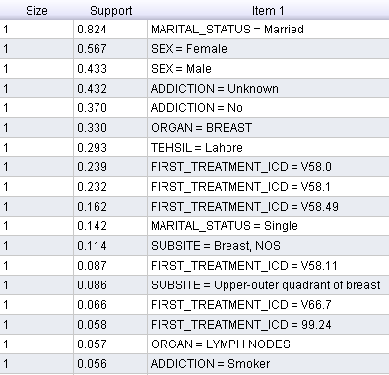

Comments of itemset size 1:
- 51000 diagnosed patients out of 62000 are married.
- 8662 patients material status is single.
- 35000 diagnosed patients are female and 26000 are male.
- 20,000 patients effected organ is breast.
- 18000 diagnosed patients belong to tehsil Lahore.
- 3416 patients got cancer due to addiction of smoking.
- 14600 diagnosed patients assigned First_treatment_icd=V58.0
- 14250 patients assigned First_treatment_icd=V58.1
- 1000 patients assigned First_treatment_icd=V58.49
- 5344 patients assigned First_treatment_icd=V58.11
- 4053 patients assigned First_treatment_icd=V66.7
- 3477 patients effected organ is LYMPH NODES.

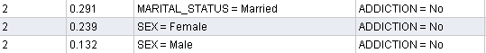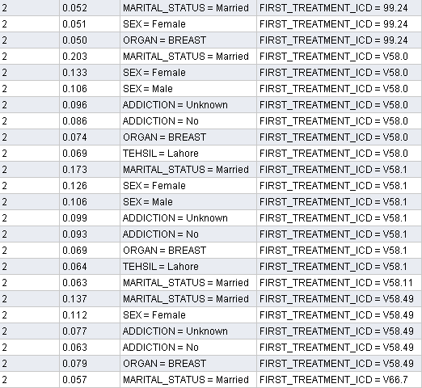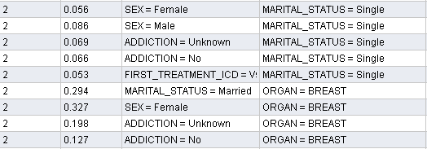

Comments of itemset size 2:

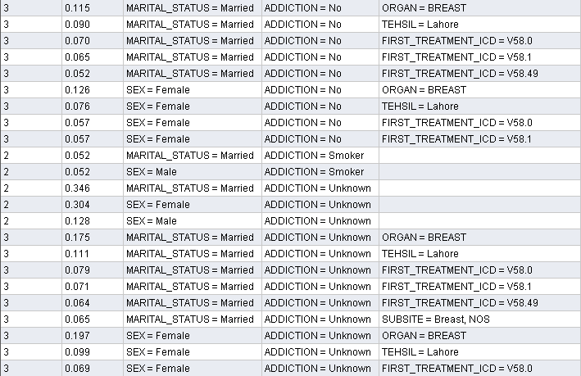

Comments:

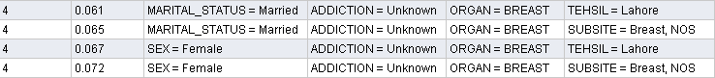

Comments:

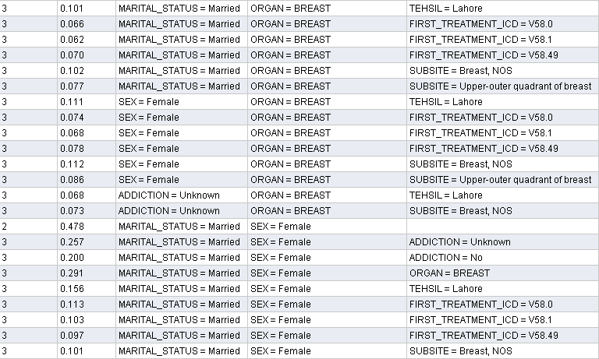
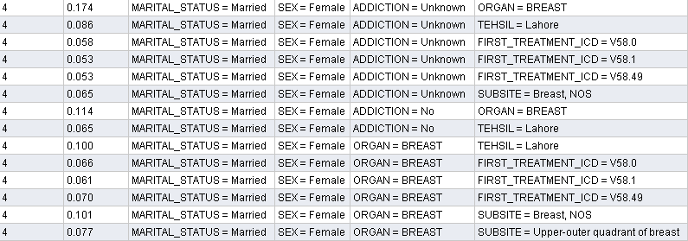

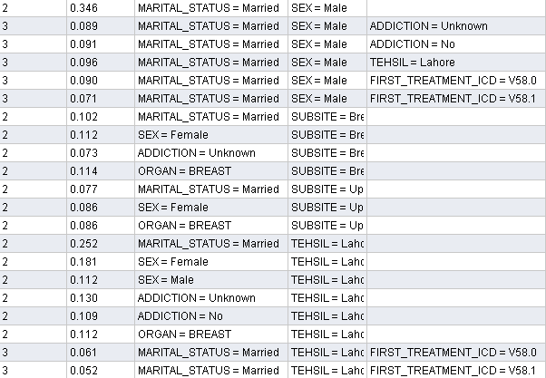

Association Rules
Min. Support 0.95

Minimum confidence 0.9

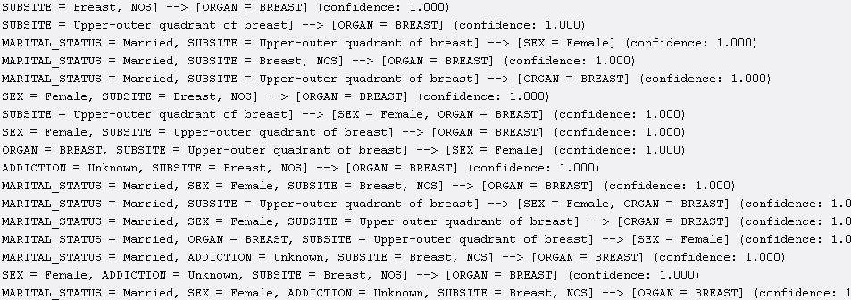

Minimum Support 0.95
Min. Confidence 0.8
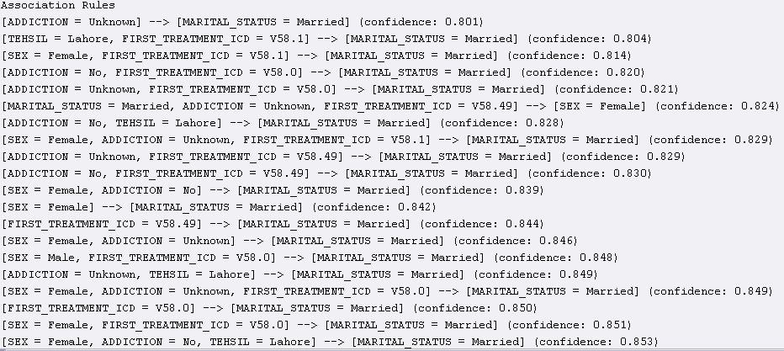
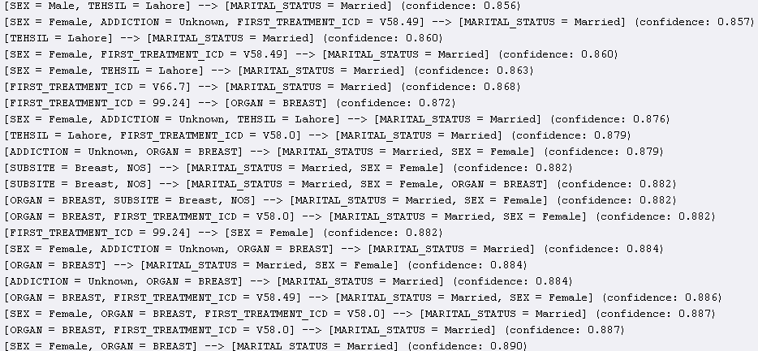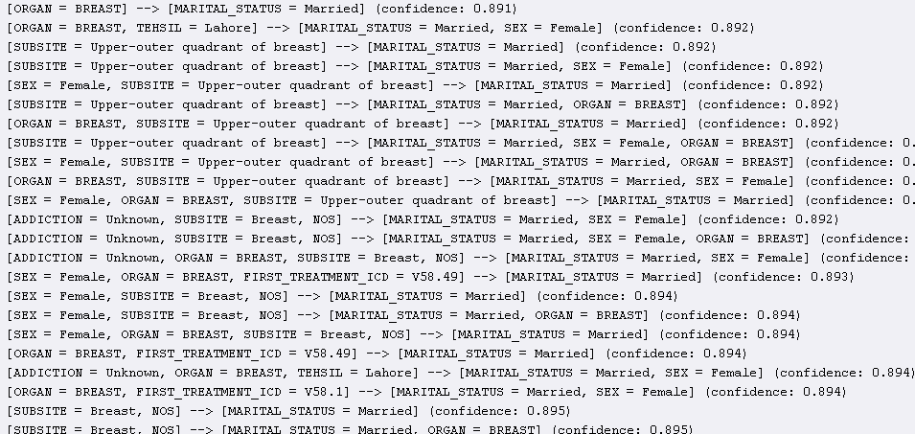
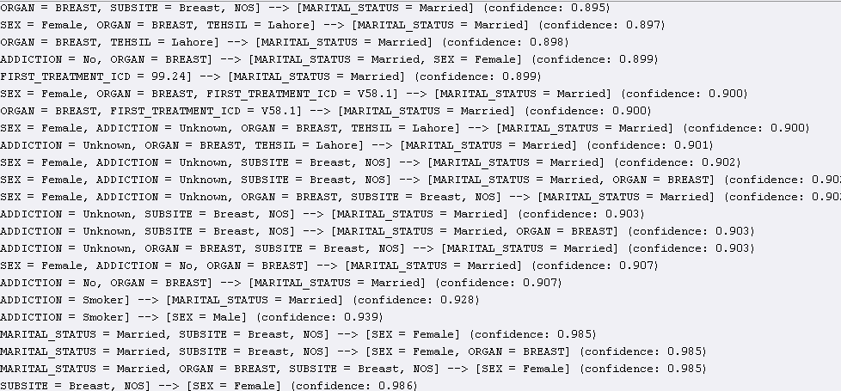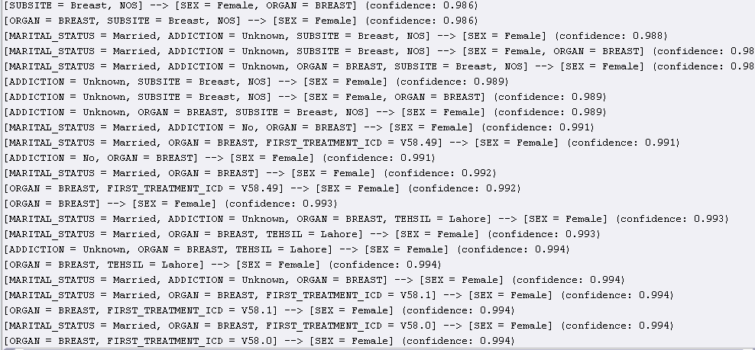
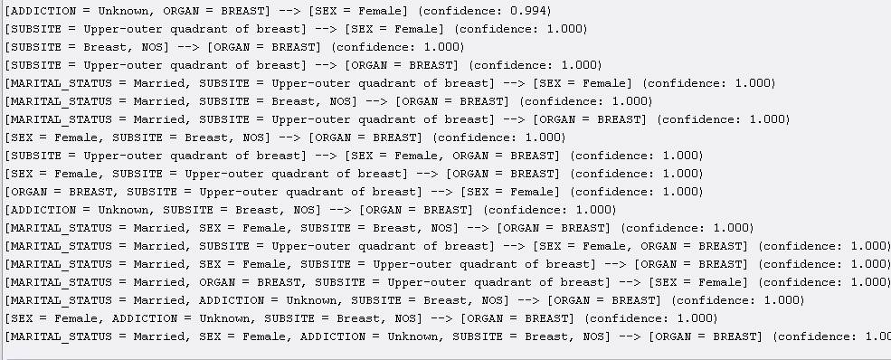

Data Dictionary

MRNO
Medical Record Number

ICD
International code for disease

MARPHOLOGY

The morphology of a cancer refers to the histological classification of the cancer tissue (histopathological type) and a description of the course of development that a tumour is likely to take: benign or malig0t (behaviour). The designation is based on a microscopic diagnosis of morphology by the pathologist (Esteban, Whelan, Laudico & Parkin 1995).[1]

PATHOLOGY

Pathology is the study and diagnosis of disease through examination of organs, tissues, bodily fluids, and whole bodies (autopsies). Pathology also encompasses the related scientific study of disease processes, called general pathology.[2]

Class 1

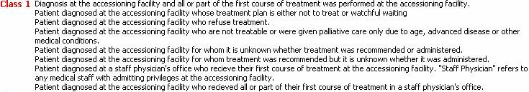

Regional lymph node positive

The total number of regional lymph nodes examined by a pathologist and reported as containing tumour. A regional lymph node is a lymph node that drains lymph from the region around a tumour.

Surgical margins

Surgical margin in a surgery reports define the visible margin or free edge of "normal" tissue seen by the surgeon with the naked eye. Surgical margin as read in a pathology report define the histological measurement of normal or unaffected tissue surrounding the visible tumour under a microscope on a glass mounted histology section. A "narrow" surgical margin implies that the tumour exists very close to the surgical margin, and a "wide" surgical margin implies the tumour exists far from the cut edge or the surgical margin.

References

http://meteor.aihw.gov.au/content/index.phtml/itemId/269647/
http://en.wikipedia.org/wiki/Pathology/
http://meteor.aihw.gov.au/content/index.phtml/itemId/289198/
http://en.wikipedia.org/wiki/Surgical_margin/

Appendix A

The following histograms shows the important facts about each attribute of the dataset.

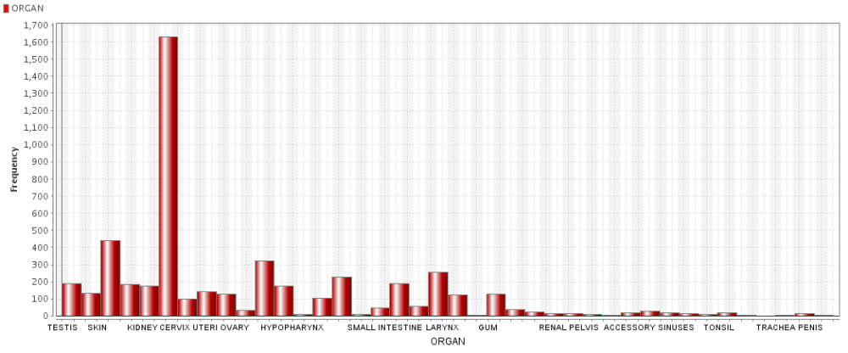
The above graphs shows that the most common cancer diagnosed is the organ “Cervix”.

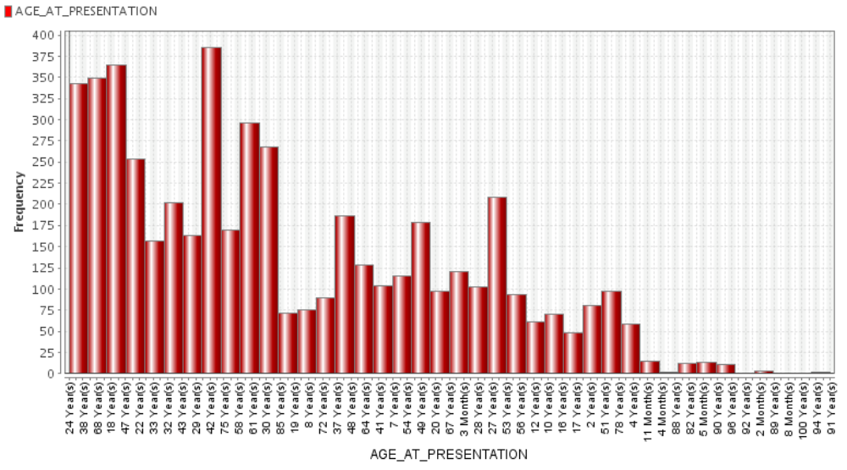

Mostly cancer is diagnosed in people having age 42 years.

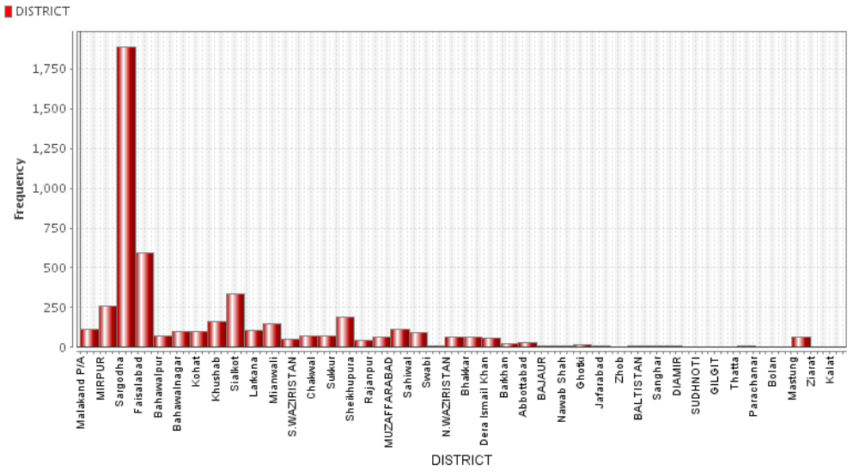

The people of Lahore are mostly affected by Cancer by given statistics.

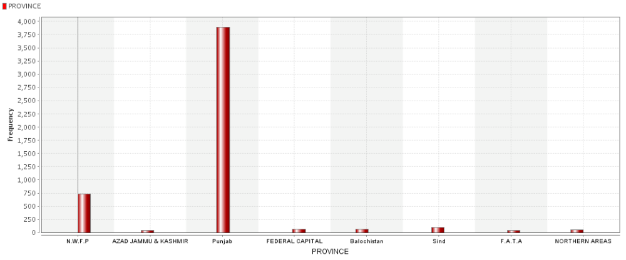

Province of Punjab has the most number of cancer patients.

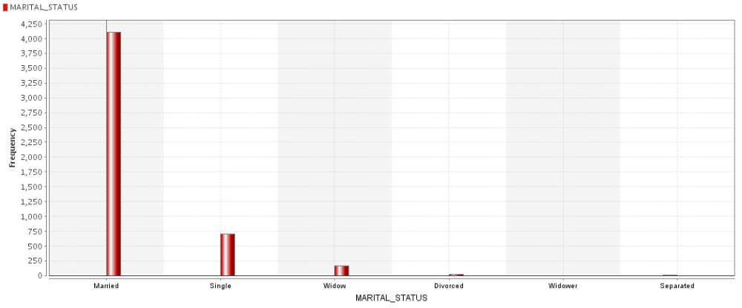

The above histogram displays that Marriad people are the frequent patient of cancer.

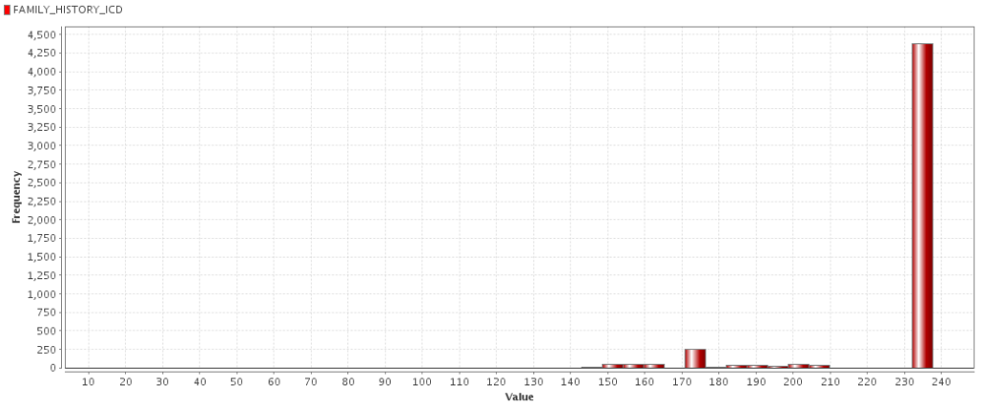
Usually the people who have ralatives having ICD 230-240 are mostly affected by the cancer

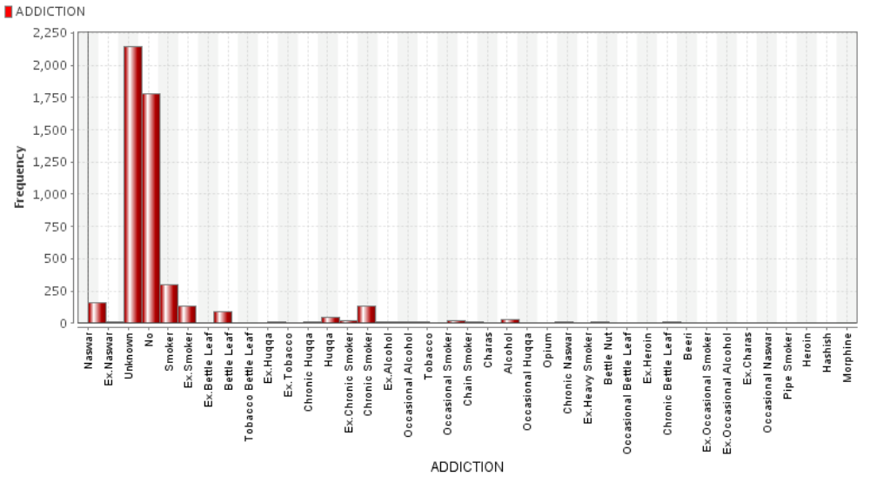
Mostly the cancer patients donot have any Addiction.

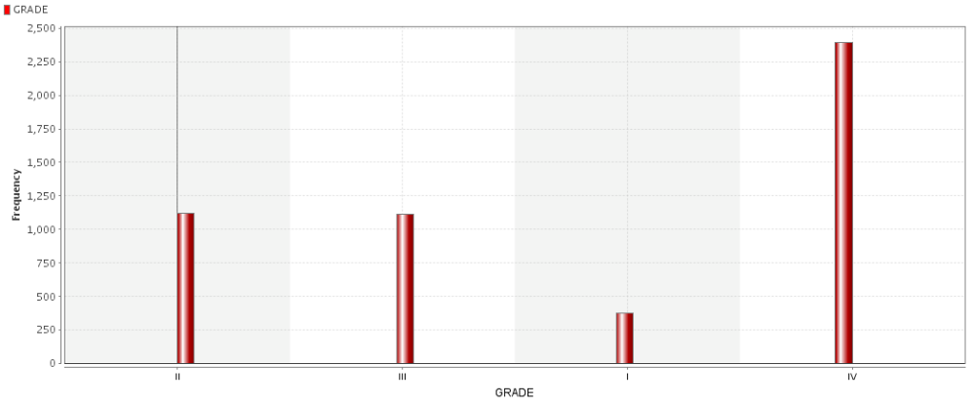
The most common cancer diagnosed is of grade IV.
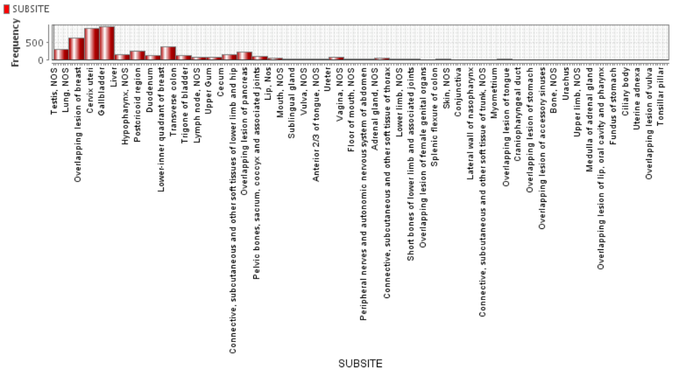

Mostly cancer is detected in Cervix uteri and Gallblader.

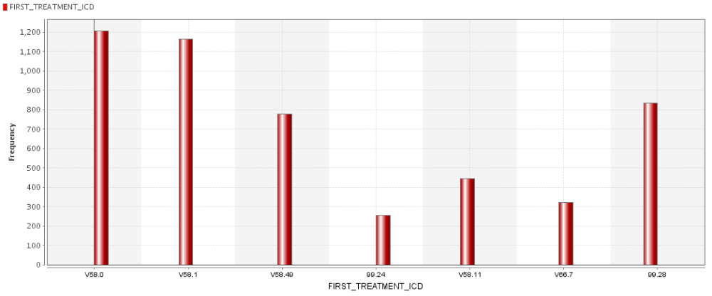
The most common ICD detected is V58.0
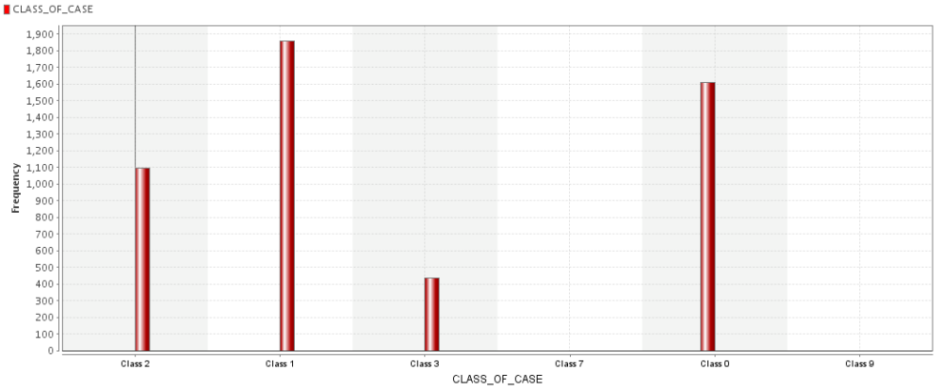
Mostly the people have cancer of Class1.

The most common type of cancer detected is Breast Cancer.

Appendix B
Scatter Plots for visualization of data

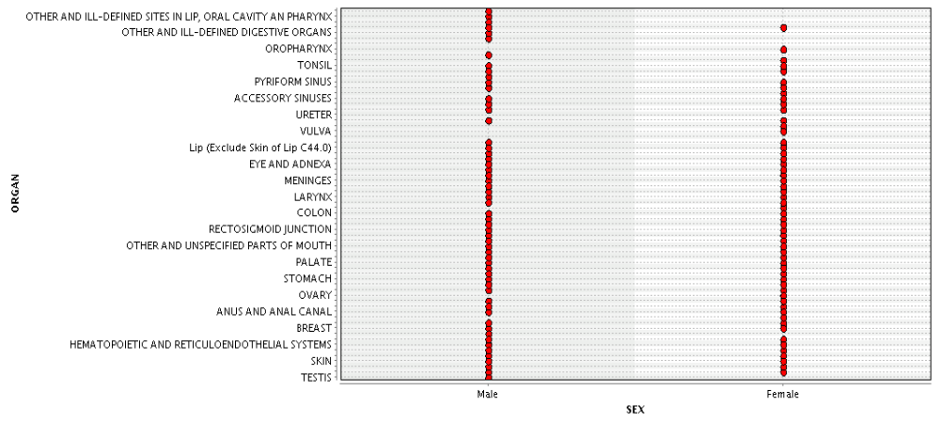

This graph shows that females don’t have any cancer diagnosed for the “ill-defined digestive organs” and “ill-defined sites in lip, oral cavity an pharynx” and mostly diagnose in these organs; breast, ovary and anal canal.
And males don’t have cancer diagnosed in vulva, or pharynx and ovary. Whereas mostly diagnosed at Testis and colon.
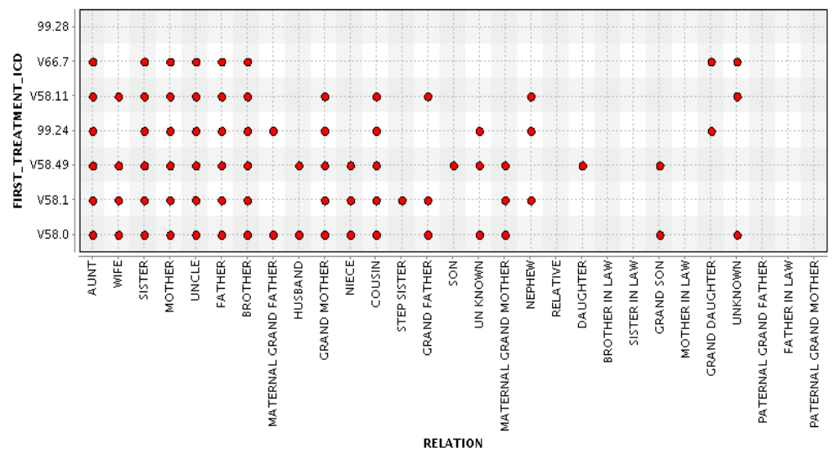

This graph shows the ICD numbers that are assigned according to specific relations.
The symbol * showing the presence of ICD allot due to relation showing in that row. Blank cells showing no ICD against that relation .

Relation | FIRST-TREATMENT-ICD
 | V58.0 | V58.1 | V58.49 | 99.24 | V58.11 | V66.7 | 99.28
Aunt | * | * | * | * | * | *
Wife | * | * | * |  | *
Sister | * | * | * | * | * | *
Mother | * | * | * | * | * | *
Uncle | * | * | * | * | * | *
Father | * | * | * | * | * | *
Brother | * | * | * | * | * | *
Maternal Grand father | * |  |  | *
Husband | * |  | *
Grand Mother | * | * | * | * | *
Niece | * | * | *
Cousin | * | * | * | * | *
Step sister |  | *
Grand Father | * | *
Son |  |  | *
Maternal Grand Father | * | * | *
Nephew |  | * |  | * | *
Daughter |  |  | *
Brother in Law
Sister in Law
Grand Son | * |  | *
Mother in law
Grand Daughter |  |  |  | * |  | *
Paternal Grand Father
Father-in-law
Paternal Grand Mother

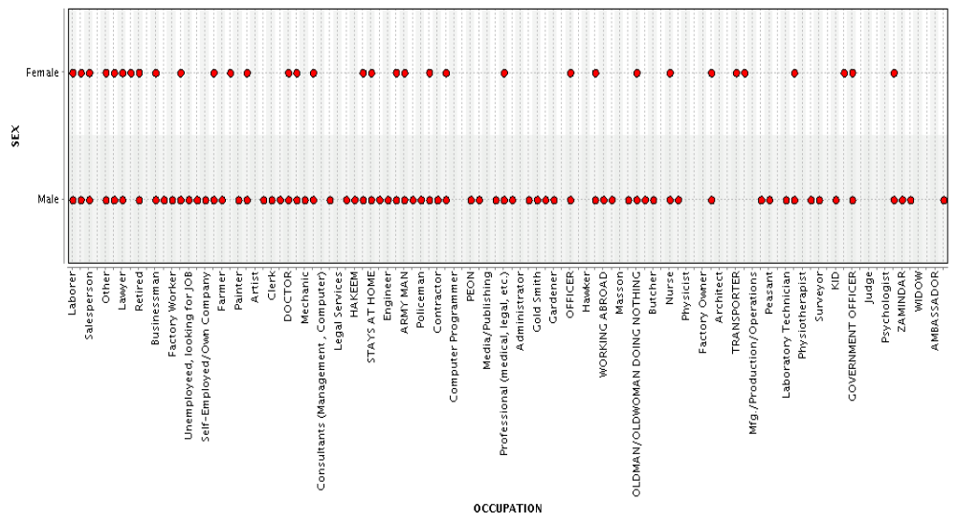

There is more span for males as they adopt different occupation whereas females work in limited fields that’s why more variations for males than females.
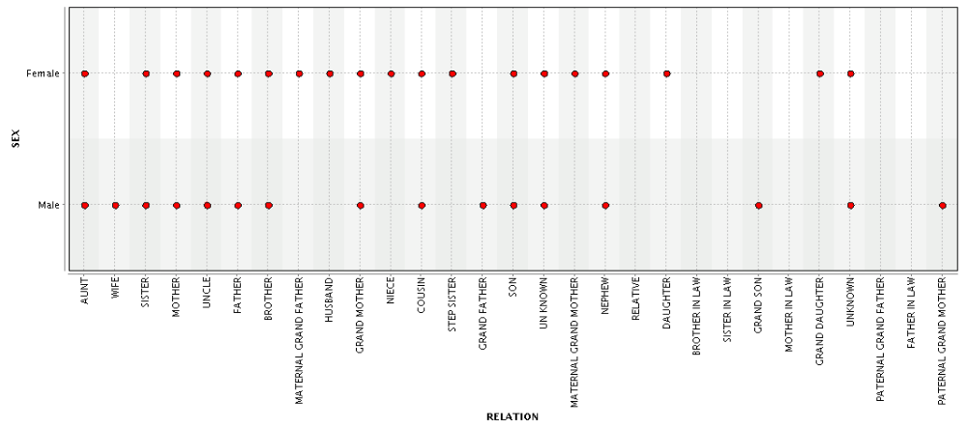

There is no cancer diagnosed for males if the relations are marital grand father, niece, step sister, daughter, sister and brother in law, mother in law, grand father and father-in-law.
Similarly there is no cancer diagnose for females if relations are grand father, mother in law, sister in law, grand son, mother-in-law and father-in-law.

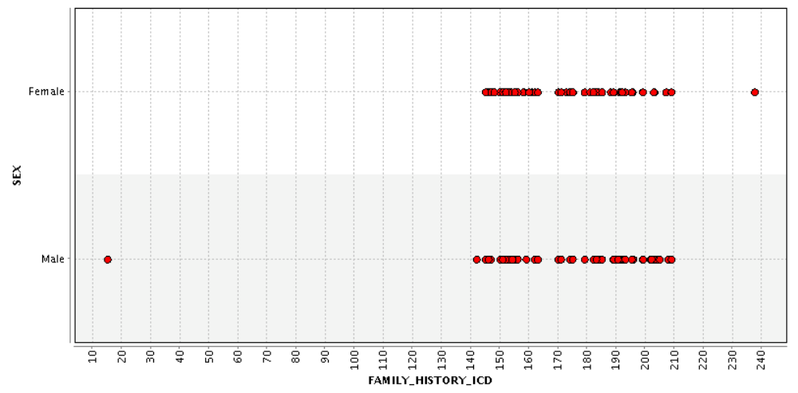
In males cancer is diagnosed due to family relation ICD mostly in the range of 140 – 210 and also at ICD 10.And for females its mostly in the range 145-208.9 and also at 237.5.

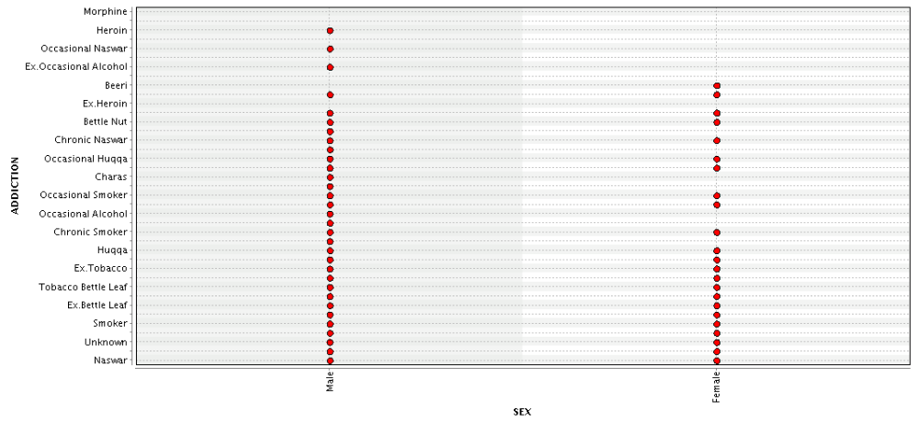
The above graph showing different addictions for both males and females. Males are more addicted while females are less addicted to addictive substances.
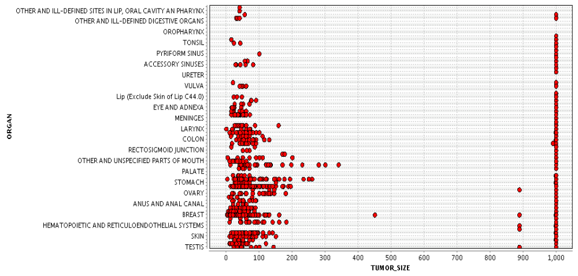

The above graph shoes that mostly all the tumors are of size 1000 when they are diagnosed but for testis,skin,breast,anal,ovary,stomach,colon,larynx and Vulva, tumor of other sizes are also diagnosed.

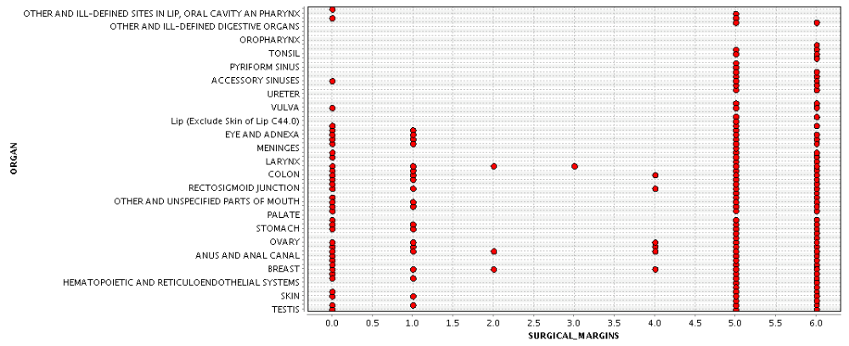

The above graph shows the sugical margin for each organ. Commonly for all organs except Orophynx and Uterer have Surgical margins of 5 and 6, which means that these cancers effect their surronded regions as well.
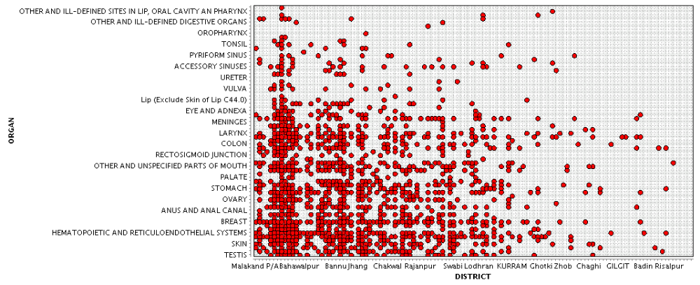
The above graph shows that almost all kind of cancers are diagnosed for the districts like Malakand and Bahawalpur. This might be due to the environment of these districts. While for Gilgit the only cancer detected are “Colon” and “Hematopoetic and Reticuloendothelial System”.

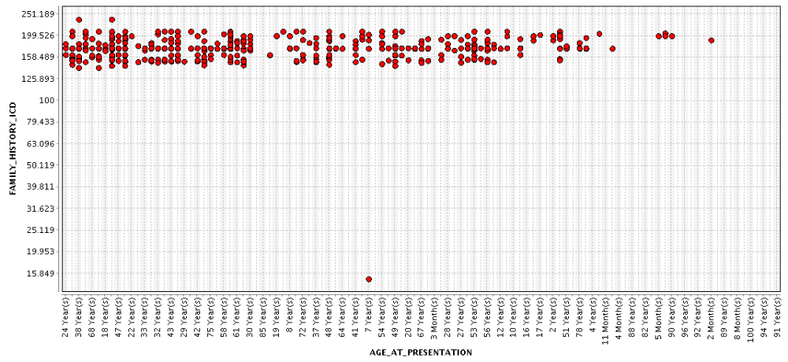

The above graph shows that if the Family_History_ICD is 15.849 then the only age in which cancer was diagnosed is 7 Years while almost in every age and Family_History_ICD of 158.409 to 199.526, the cancer is diagnosed.

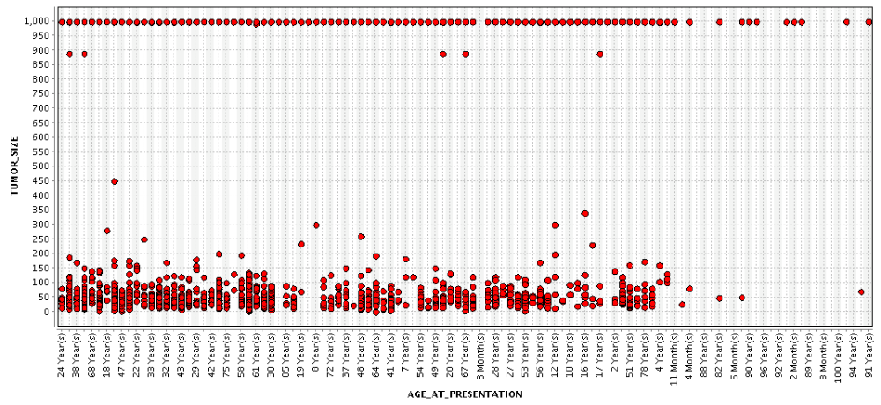

This graph shows the different tumour sizes for different ages. As we can see that 1000 Tumour size is diagnosed in almost all ages.

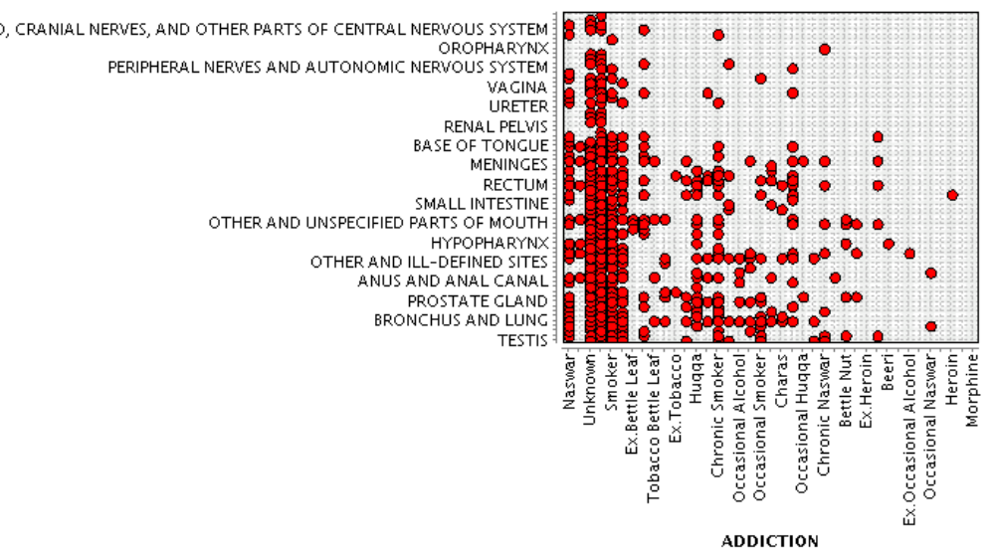

This graph shows the effects of addicted materials on different organs some important are showing below:-

Addictive Materials | Organs
Naswar | Testis,Skin,Prostrate grand, Anus and anul canal,unspecified parts of mouth,Rectum,Meninges, base of tounge, pyriform sinus and ill-defined sites in lip, oral cavity an pharynx
Smoking | Testis, Prostrate grand, Anus and anul, Meninges, base of tounge,hypopharynx,small intestine.rectum, peripheral nerves , autonomic nervous system and other parts of nervous system
Tobacco battle leaf | Bronchus and lung, Anus and anal canal, unspecified parts of mouth and Meninges
Huqqa | Bronchus and lung, unspecified parts of mouth, Anus and anal canal, hypopharynx and Rectum
Beer | Hypopharynx
Herion | Rectum

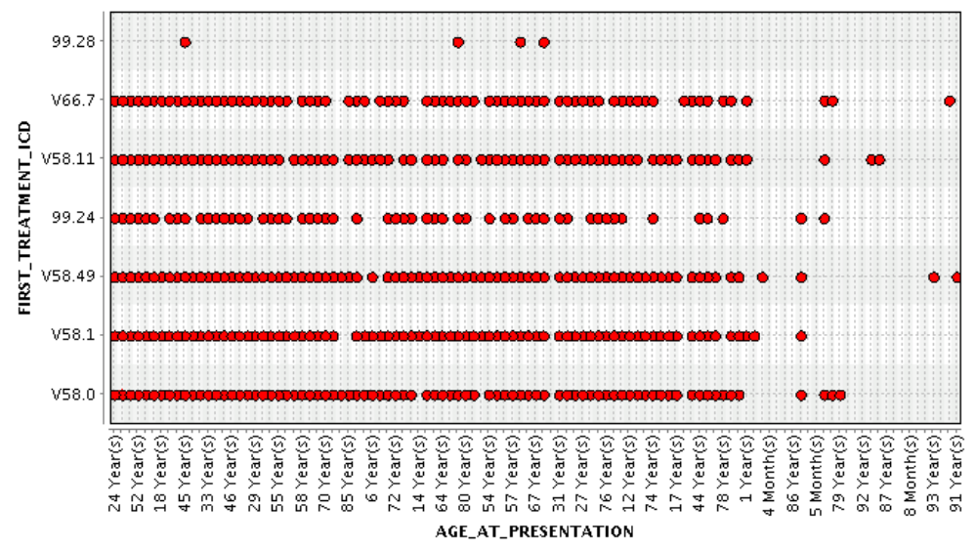

This graph shows the ICD(International code for disease) allocation among different ages.

Like for;
- 24,52,18,33,46,29,55,58,70 years old persons ICDs are v58.0,v 58.1,v58.49,v58.11,v66.7
- 85 year old patients don’t have v58.0,v58.49,v58.11,v66.7
- 45,57,67 years old patients normally have ICD 99.28 with others too.
- 91,92 years old have V58.11 ICD.
- 5-8 Months patients have V58.0

